# Examples after stage 1 (images from dataset):

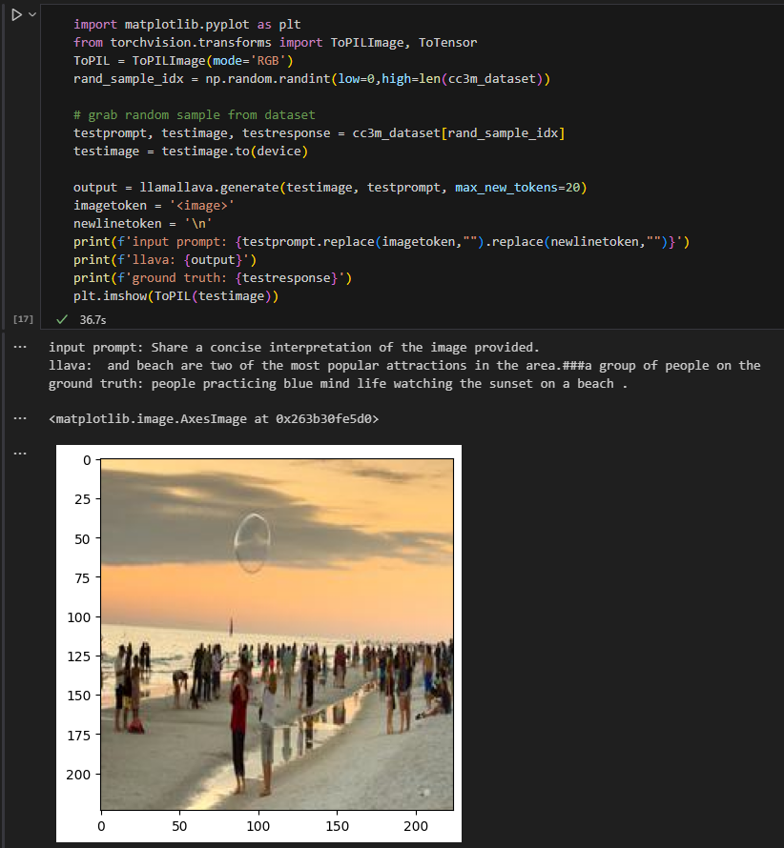

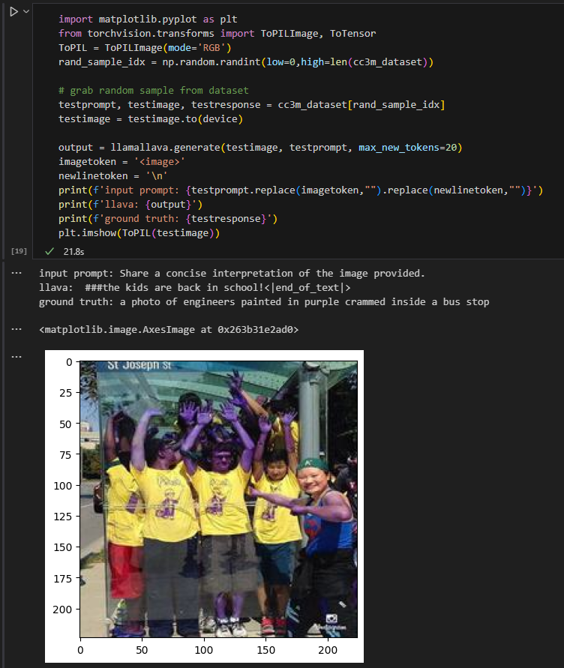

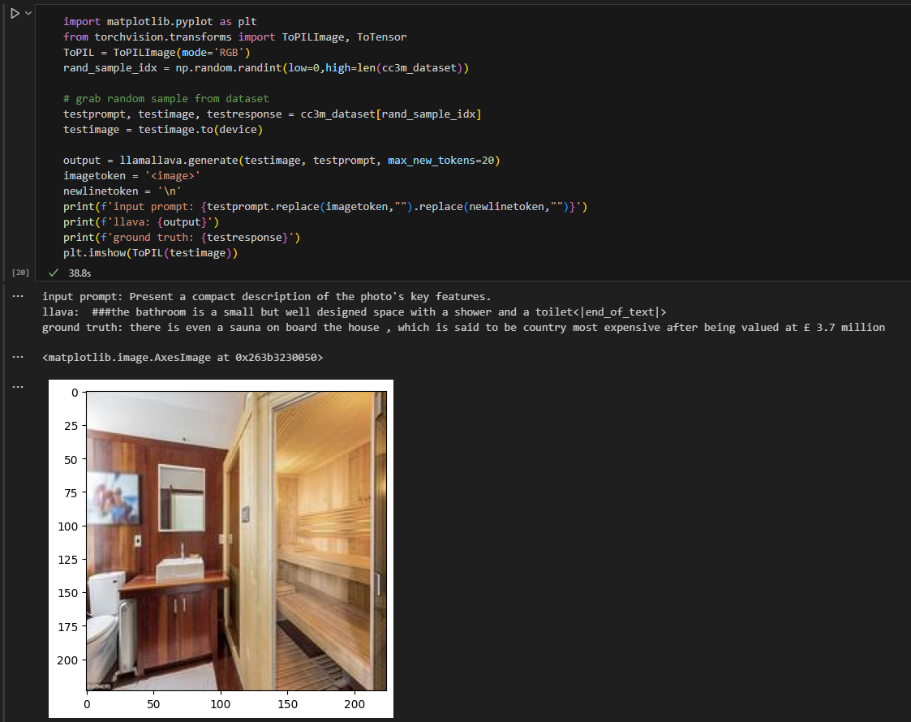

# Examples after stage 1 (images not in dataset):

This example shows an in-distribution prompt given with a random image

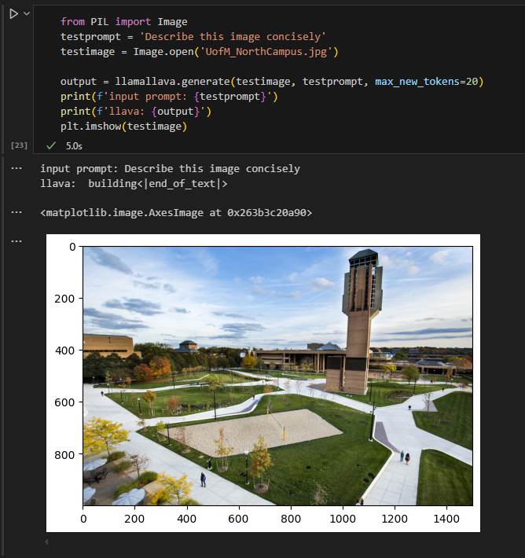

This example shows an out-of-distribution prompt with the same image. Asking a bit of a complex reasoning question and seeing how it does after stage 1 (unsurprisingly it resorts to just describing the image since that’s all it was trained on)

